Upper Pine PAC Meeting Minutes
Jan 11/21

Attendance (via Zoom): Pam, Hannah, Sarah, Melanie, Danielle, Madison

Call to Order.
Pam called the meeting to order at 7:03 pm

Review Agenda and Minutes from Previous Meeting
Request additions to agenda
Madison asked if we could discuss the meeting times for the next meeting – possibly moving from evenings to different times.

Motion to Approve Agenda and Approve Minutes from Previous Meeting
Sarah motions, Madison seconds. All in favour – motion passed.

Reports
Principals Report
Mrs. Braun was not able to attend the meeting. Her notes are attached.

Questions for Mrs. Braun –
Is there a reasoning for Mrs. Johnson’s class to still be in the portable now that Ms. S. has switched classrooms?
Skate Shack – are deadbolts being added to doors since there was already a break in?
Any word on if the Grade 8’s will be able to take their tour of Dr. Kearney to prepare for next year?

Treasurer Report
Bank balance (general) is $15,444.82.
Bank Balance (gaming) is $4,504.52.
Report is attached.

Pam & Danielle presented an updated budget for both accounts.
Originally the PAC had budgeted $1500 to finish the rink matting. Upon seeing how the rink is being used, the deck boards are getting beat up by skate blades. Another 6 mats are needed to finish the matting. Pam motions to purchase another 6 mats from Braun’s Flooring and take the funds from the gaming account. Hannah seconds. All in favour – motion passed. Pam will also talk to Mrs. Braun about security for the skate shack and who will monitor and maintain.

Danielle motions to accept the treasurers report for January. Pam seconds. All in favour – motion passed.

Fundraising Report
Paid for 2 pallets of ice melt from Nutrien. Danielle is going to inquire at the bank about the cost of getting a visa machine for the PAC. One pallet will be delivered to the school this week – just need to set up a time for someone to help unload.

Danielle – Purdy’s fundraiser for Easter? Need to double check with Mr. Neufeld as the PAC does not want to interfere with his chocolate sales.
Make is Sow – given the pandemic year and run-on seeds, could be a good seller. Pam will contact.

Tony at Nutrien asked if we wanted to try the fertilizer fundraiser again. When the PAC did this fundraiser in the past it netted $1750. Yes, to this fundraiser.

The PAC would also like to continue the flowerpot fundraiser from Norbert. Pam will contact.

DPAC/SUPAC
See Madison’s notes attached.

Hannah will attend the next meeting via Zoom.

Volunteer/Communications Coordinator Reports
No volunteers needed for December.

Sign Coordinator Reports
Stephanie has been changing the sign – talking to Darcy about updates.

Hot Lunch Report
Allowed to have hot lunch dates w/ 3 people only. Kids will deliver.

Tentative: January 27th – Pam will talk to Mrs. Braun and Stephanie.
Will make baked spaghetti.

Madison suggests doing a “donut day” instead of normal float days. Madison will enquire about cost of donuts and pre-orders. **Email was sent after the meeting from Madison with all the information. See below:
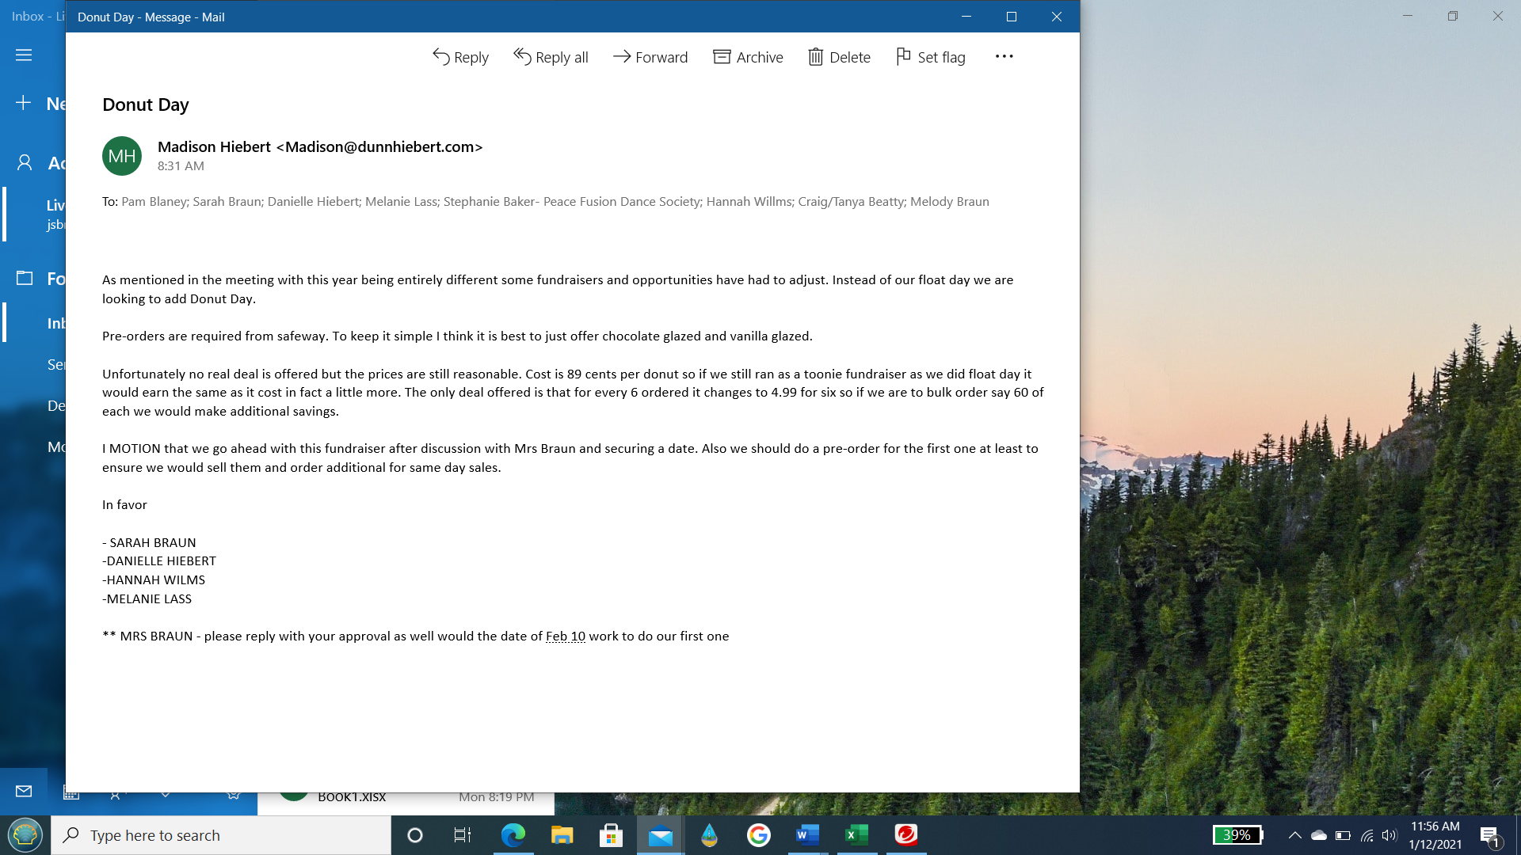

**Pam seconds the motion. Mrs. Braun emailed back to say that February 10th works for them. All were in favour. Motion passed.

Review of Action Items

UPPER PINE PAC MONTHLY MEETING
ACTION PLAN FROM MEETING (Dec 7^{th)}
ITEM | WHO | BY WHEN | CONFIRM  COMPLETE
Digitize PAC notes and files. Set up google drive docs. | Madison | January 11/21 | Madison spoke on this – See PAC notes
Masterpiece Framing – Sign for gazebo and c-can. | Pam | January 11/21 | Pam will follow up – she told him she would like this done by Spring Break
Mrs. Gilmour – Banana intolerance and students being told not to bring? | Mrs. Braun | January 11/21 | Done – Mrs. Braun answered
Rink – Wes Babcock and Bradley McGinnis to flood? | Pam | January 11/21 | Done
Should PAC have a written policy/agreement with school that states once items purchased by PAC that they are property of Upper Pine School? Thoughts? | PAC Exec. | January 11/21 | To be reviewed again in February.
Dieleman’s – cheque for 42% of fundraising. Pam to email. | Pam | January 11/21 | Done – deposited.
Hot Lunches/Float days allowed to happen with parent volunteers? | Mrs. Braun | January 11/21  (Administrator meeting Dec 8/20) | Done – Mrs. Braun answered.
Soft Audit – Bank statements, cheque book, budget, and books to go to Darcy to do a check that all is in order. | Pam/Danielle | January 11/21 | Danielle and Pam to meet with Darcy Wed or Thursday. Will be done by next meeting.
Coffee Connect | Pam | January 31/21 | Tentative date of Jan 27th.

Digitize PAC Notes
Madison was able to speak with Corrie Bennie. She suggested using our Gmail account and google drive to help with the digitizing process. She also suggested having another email address for the treasurer to have a backup copy of the files in case the main email was ever compromised. Corrie also suggested before we do anything, we review our Constitution and Bylaws to see how long we are required to keep notes and files and possibly add a pandemic clause into it.

Corrie offered to help the PAC get this set up. Madison will set up a time with her. **Jan 12/21 – Madison set up a time with Corrie to meet. Jan 22 at 11:30. Pam, Danielle, and Sarah will also attend.

Coffee Connect
Pam going to try again – tentative January 27^{th.}

PAC Policy – School property vs PAC property
Discuss again at next meeting. Need to find a way to have the inventory of what the
PAC has bought be accessible to it is used by staff and students. What to do if the PAC purchases an item or builds something for the school and part of it needs to be maintained? Does this become responsibility of SD60 maintenance? Needs clarifying before end of school year.
Hannah will ask at the next DPAC meeting what other schools do in these situations.

New Business
PAC Goals – table till next meeting
Jan – March
After Spring Break
Long term?

Conclusion
Meeting adjourned at 8:41 PM.

Next meeting will be on Wednesday, Feb 3rd at 1 PM via Zoom. Pam will talk to Mrs. Braun about joining in after school is over.

